Assignment

1. Introduction
Microservices architecture is a modern software design approach in which an application is built as a collection of small, independent services that communicate with each other using APIs. Each service performs a specific function and can be developed, deployed, and scaled independently.
In this assignment, a Bookstore Microservices Application is implemented using two Virtual Machines (VMs) created in Oracle VirtualBox. One VM hosts the Frontend service, while the other hosts the Backend service. The services communicate with each other using REST APIs over a Host-Only Network.
The objective of this assignment is to:
- Understand virtualization using VirtualBox
- Implement microservices using Node.js
- Configure networking between multiple VMs
- Demonstrate service-to-service communication

2. Architecture Diagram

Architecture Overview
The system architecture consists of:
- A Host Machine (User System)
- Two Ubuntu Server Virtual Machines
- A Host-Only Network for internal communication

Architecture Description
- The Host Machine accesses the application through a web browser.
- VM1 (Frontend Microservice) listens on port 8080 and handles user requests.
- VM2 (Backend Microservice) listens on port 3000 and provides book data through a REST API.
- VM1 communicates with VM2 using Axios to fetch data.
- VM2 responds with JSON data, which is rendered as HTML by VM1.
IP Address Scheme

Component | IP Address | Port
VM1 – Frontend | 192.168.56.10 | 8080
VM2 – Backend | 192.168.56.11 | 3000
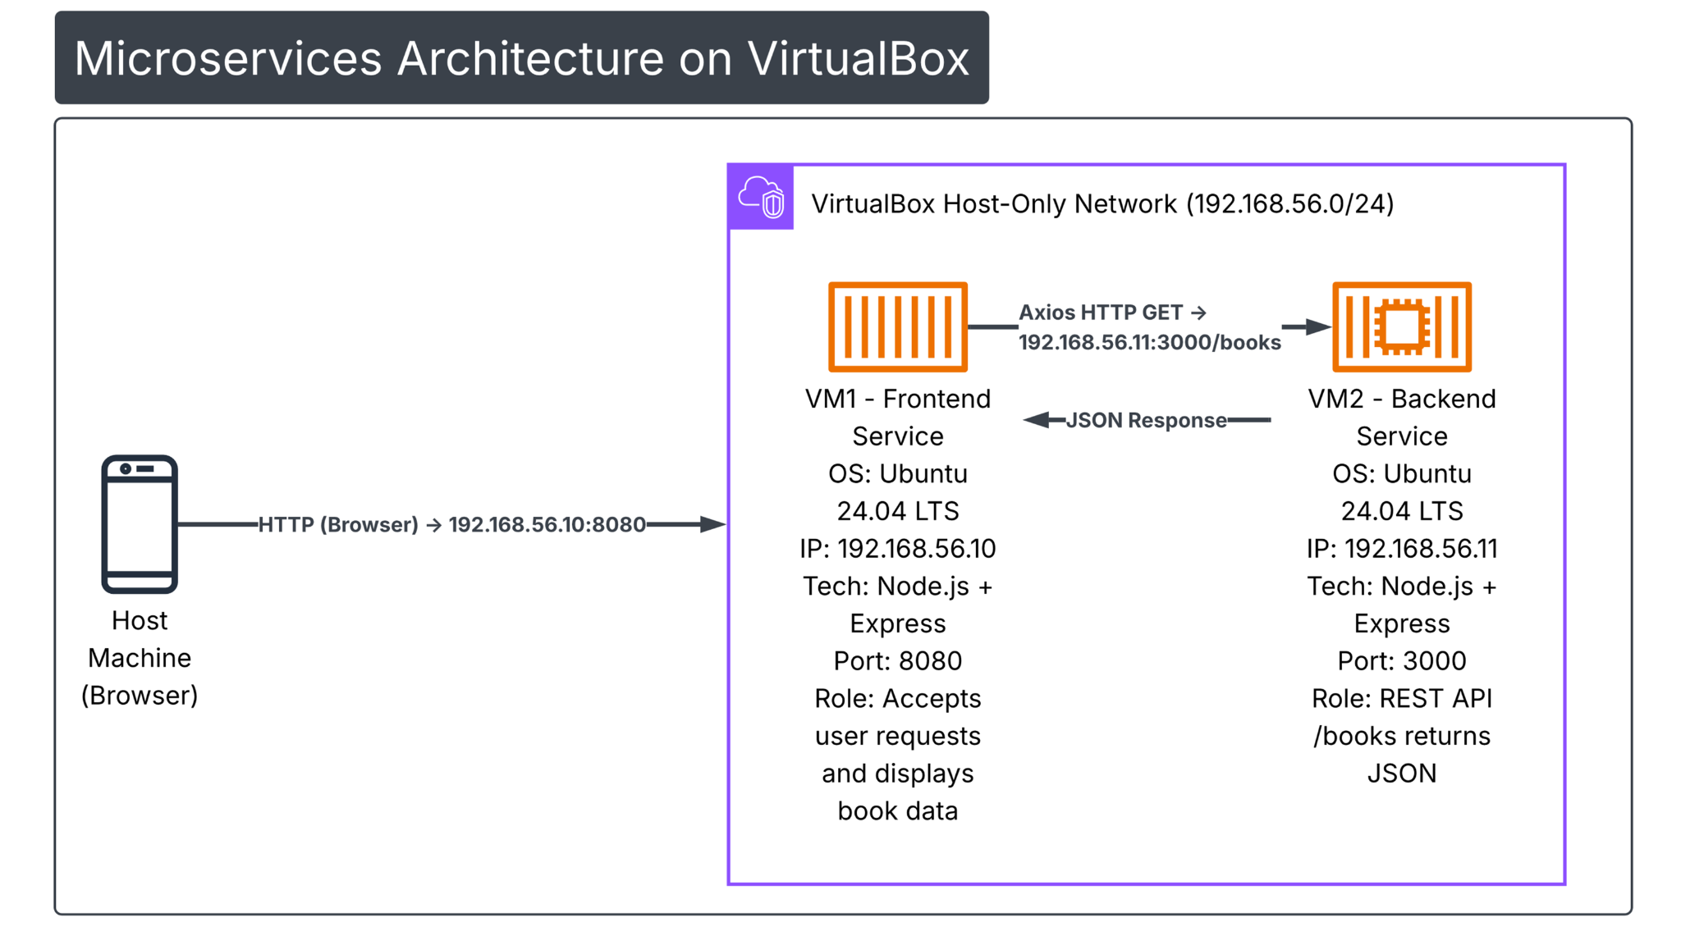
3. VM Configuration
Two virtual machines were created using Oracle VirtualBox with the following configuration:

Common Configuration (VM1 & VM2)

- Operating System: Ubuntu Server 24.04 LTS
- RAM: 2 GB
- CPU: 1 Core
- Storage: 25 GB (VDI)
- Display: Default
- Virtualization: Enabled

VM Roles
VM Name | Role
Microservice-VM1 | Frontend Service
Microservice-VM2 | Backend Service

Each VM runs independently and hosts a single microservice.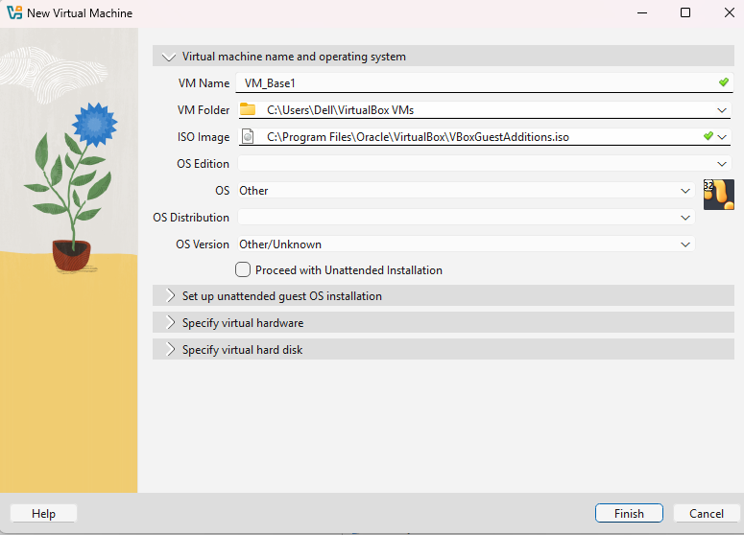
Clone VM
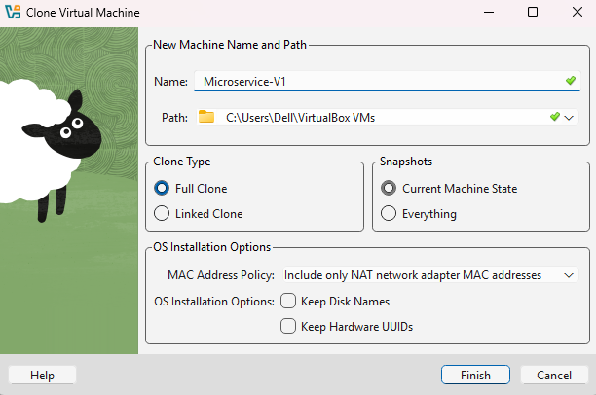

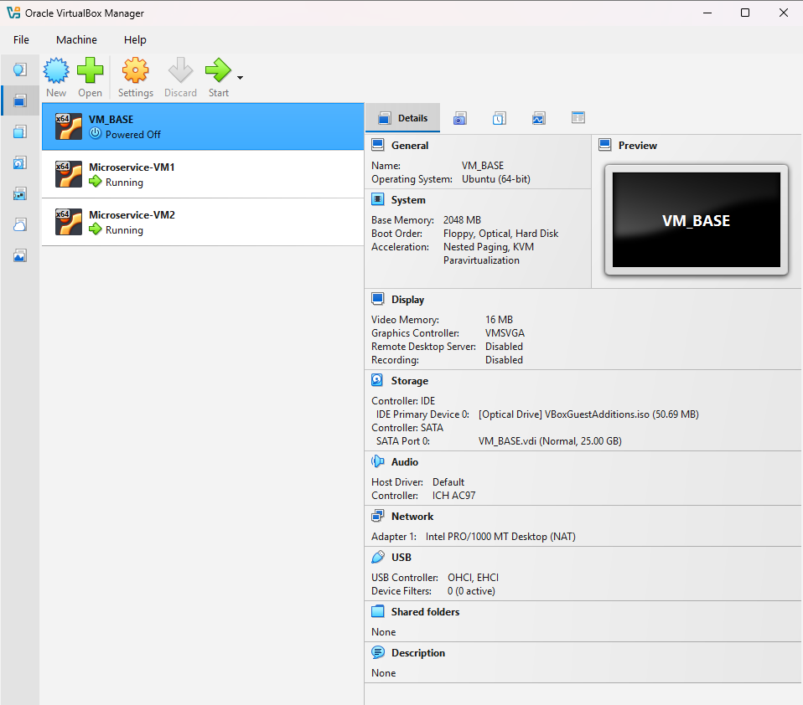

4. Network Configuration
VirtualBox Network Setup
- Adapter 1: NAT
  - Provides internet access for installing packages.
- Adapter 2: Host-Only Adapter (vboxnet0)
  - Enables private communication between VMs.
Static IP Configuration (Netplan)

VM1 (Frontend)
network:
version: 2
ethernets:
enp0s3:
dhcp4: true
enp0s8:
dhcp4: no
addresses: [192.168.56.10/24]

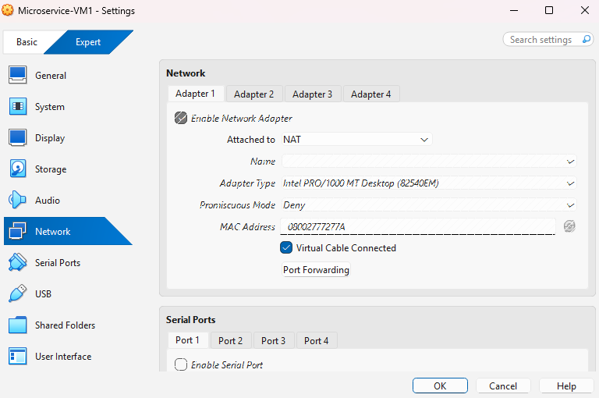
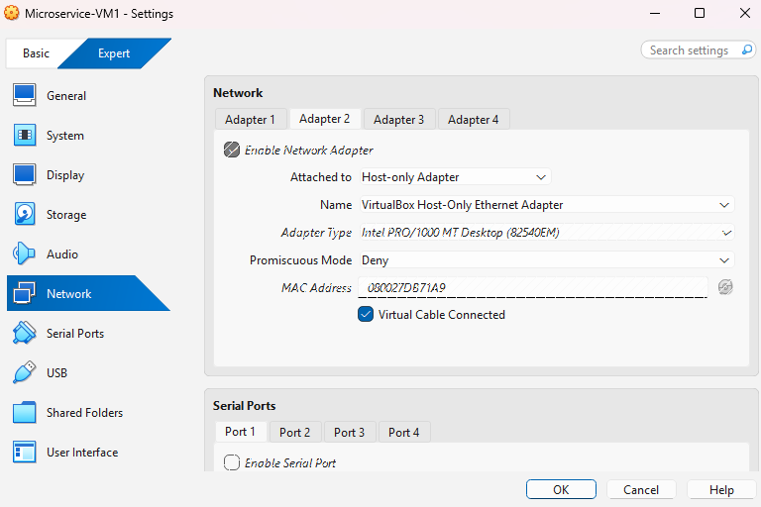

VM2 (Backend)
network:
version: 2
ethernets:
enp0s3:
dhcp4: true
enp0s8:
dhcp4: no
addresses: [192.168.56.11/24]
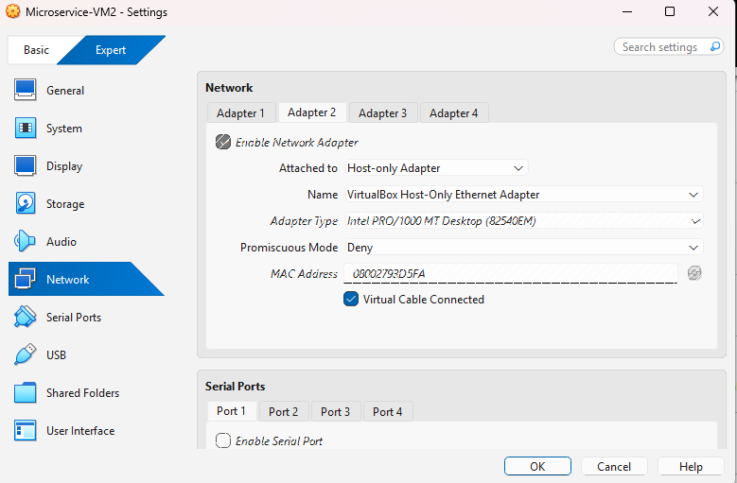
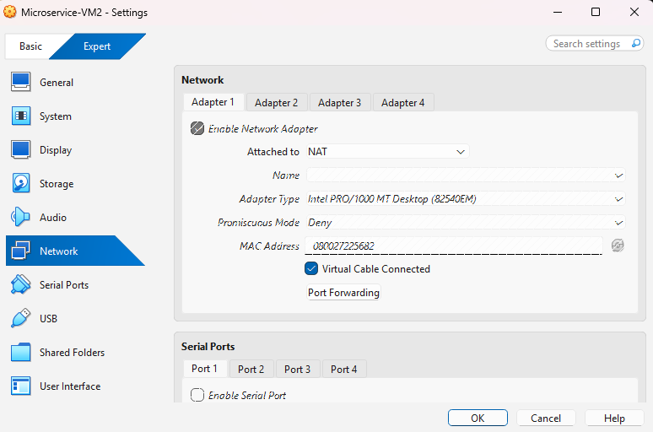

Connectivity was verified using the ping command between both VMs.
5. Backend Implementation (VM2)
Technology Stack
- Node.js
- Express.js
Functionality
- Provides a REST API endpoint /books
- Returns book details in JSON format
Backend Code Summary
- Express server listens on port 3000
- API endpoint responds with a list of books

Execution
node index.js

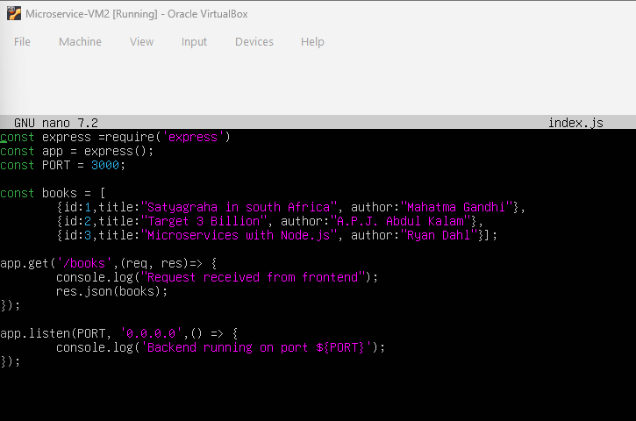

6. Frontend Implementation (VM1)
Technology Stack
- Node.js
- Express.js
- Axios
Functionality
- Handles HTTP requests from the user
- Sends API requests to the backend
- Converts JSON response into HTML
Backend API Call
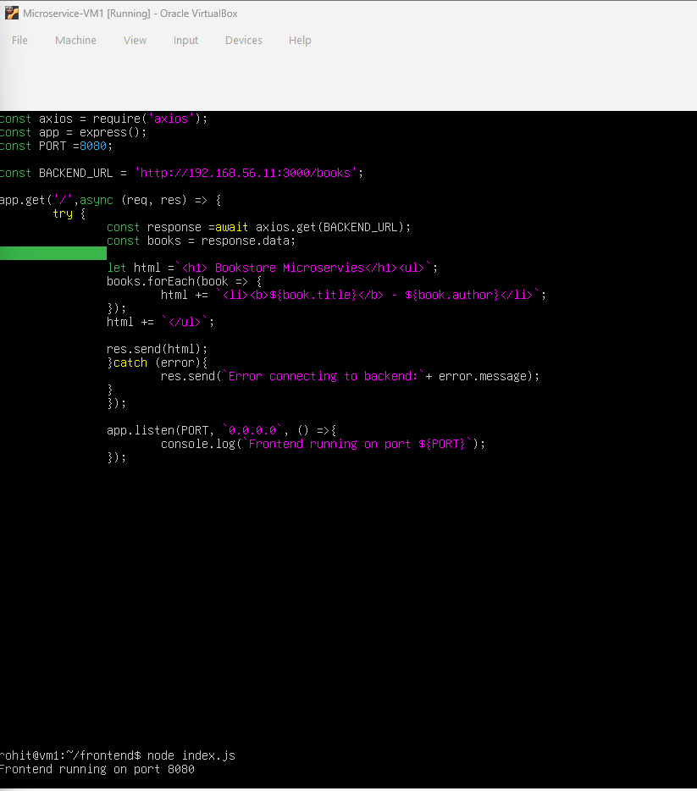
The frontend service runs on port 8080 and serves content to the browser.

7. Results & Screenshots
Successful Outcomes
- Static IP configuration applied successfully
- VM1 and VM2 communicate via Host-Only Network
- Backend API returns correct JSON response
- Frontend displays book list in browser
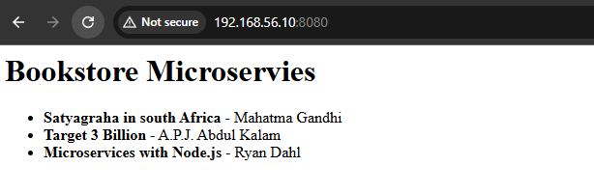

8. Conclusion
This assignment successfully demonstrates the implementation of a microservices-based application using Oracle VirtualBox. By separating frontend and backend services into independent virtual machines, the project showcases service isolation, REST-based communication, and practical networking concepts.
The system validates key microservices principles such as:
- Independent deployment
- Scalability
- Loose coupling
- Virtualized infrastructure
Overall, this project provides hands-on experience with virtualization, networking, and microservices deployment in a real-world scenario.

Submitted By: Rohit Paliwal
Roll No.: G25AI1069
GitHub link: https://github.com/PYTHONrohit7/microservice-assignment.git

